Position Title | Disability Justice Liaison Officer
Classification | ASO5

Position No.
Responsible to | Community Liaison Supervisor
Number of direct reports | Nil
Number of indirect reports | Nil

The Legal Aid Commission (ACT) (Legal Aid)
Legal Aid was established under the Legal Aid Act 1977. Its mission is to promote a just society in the Australian Capital Territory by:
→ ensuring that vulnerable and disadvantaged people receive the legal services they need to protect their rights and interests
→ developing an improved community understanding of the law, and
→ seeking reform of laws that adversely affect those we assist.

Further information about Legal Aid can be found at http://www.legalaidact.org.au
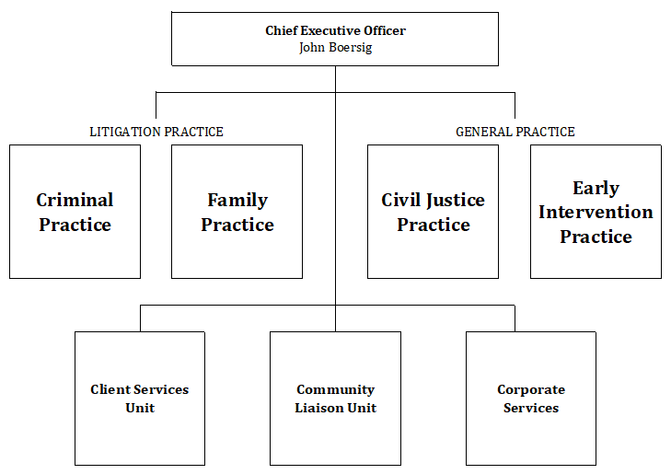

Community Liaison Unit
Legal Aid’s Community Liaison Unit provides non-legal support services to clients, across Aboriginal and Torres Strait Islander liaison services, cultural liaison services, family violence support, FASS mental health liaison services, youth liaison services, and disability justice support services.

Position Dimension and Relationships
The Disability Justice Liaison Officer has been established to foster a shared approach to providing access to justice to people with disability. This is a funded position as part of the ACT Disability Justice Strategy. The role will support the development of a cross system community of practice that will identify and address systemic barriers that impact access to justice for people with disability.

The community of practice will support a cultural shift in justice agencies to identify and meet the needs of people with disability through coordination of training, resource adaption and engaging with service users.

The Disability Justice Liaison Officer will support the organisation to develop and implement training programs, adapt resources, identify and provide for any necessary reasonable adjustments and undertake other activities that contribute to enhanced access to justice for people with disability.

Essential Duties and Responsibilities
Under general direction, the Disability Justice Liaison Officer will:
- Represent Legal Aid in a professional manner by upholding the ACT Public Service Values
- Support the progression of the Disability Justice Strategy and contribute to work around data gathering, information sharing, and developing policy and practice
- Assist staff to provide reasonable adjustments as needed, and ensure clients are supported and aware of their responsibilities and role in each stage of the legal process
- Support people with disabilities to navigate complex systems, including providing appropriate referrals
- Work with other justice community of practice members
- Facilitate upgrade of Legal Aid materials into Easy English and plain English
- Identify and implement actions to address systemic barriers to access justice
- Facilitate disability awareness training for Legal Aid staff
- Engage and liaise with community members with disabilities
- Establish and maintain working relationships, actively engaging with community organisations, NGO’s, and government agencies
- Be responsible for applying WHS to daily tasks performed in the workplace, report all matters beyond your authority and take all practical measures to ensure that your workplace is safe and without risk to health or property
- Comply with all Legal Aid ACT policies and procedures
- Perform other duties as directed, consistent with the classification level of the position and in line with competencies

Key Capabilities
Essential:
- Demonstrated engagement with people with disability, and knowledge of the issues people with disability experience in relation to accessing justice. Ability to work with people experiencing physical, intellectual and mental health challenges
- Demonstrated knowledge and sensitivity to the compounding disadvantage experienced by people with disability, and social and legal factors affecting people with disability, their families and communities
- Well developed interpersonal, written and oral communication skills
- Initiative, sound judgement and the capacity to respond to requests for assistance in urgent matters while working in a team environment
- Ability to work with minimum supervision, under pressure, to set work priorities and to meet competing and tight deadlines
- Ability to develop effective working relationships
- Ability to prioritise self-care for mental health and wellbeing

Desirable:
- Lived experience

