Position Description
Position Title | Assistant Director, Assessments
Classification | Senior Officer Grade C (SOG C)
Salary | $125,344 - $134,527 + super
Location | Canberra
Position Number | P59043
Reporting To | Senior Director, Assessments
Position Requirements | A security clearance, or the ability to obtain and maintain a security clearance at the Negative Vetting Level 1 (NV1)
Contact Officer | Henry Gittleman – Senior Director, Assessments  (02) 5132 9327 or henry.gittleman@integrity.act.gov.au
Last reviewed | September 2026

Agency overview
The ACT Integrity Commission (the Commission) is an independent integrity agency with powers under the Integrity Commission Act 2018 (the IC Act) to investigate, expose and prevent corruption and foster public confidence in the integrity of government.
Under the Public Interest Disclosure Act 2012 (the PID Act), the Commission is also responsible for receiving, assessing, referring, and investigating reports of disclosable conduct, deciding which reports are to be treated as Public Interest Disclosures (PIDs), and performing an oversight role of ACT public sector agencies in their management of PIDs.
The Commission’s functions are to:
- investigate allegations of corrupt conduct
- refer suspected instances of criminality or wrongdoing to the appropriate authorities
- prevent corruption through research and mitigation efforts
- publish information about investigations, including lessons learned
- provide education programs
- foster public confidence in the Legislative Assembly and ACT public sector
- receive, assess, refer, and investigate reports of disclosable conduct and
- oversee ACT public sector agency management of public interest disclosures.
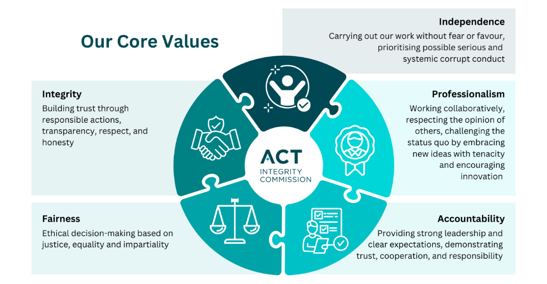

Business unit overview
This position sits within in the Assessments Team, which serves as the “front door” for the Integrity Commission, receiving and assessing reports of alleged corrupt and/or disclosable conduct from the general public, ACT government employees, mandated reporters and other government and private entities.
The Assessments Team is responsible for making recommendations to the Integrity Commissioner on how the Commission should deal with each report received under the Integrity Commission Act 2018, with the available options being to dismiss, refer or investigate matters received. In the process of developing these recommendations, team members are responsible for gathering and analysing relevant evidence through interviews of complainants, open-source research, application of preliminary inquiry powers, and the preparation of comprehensive assessment reports. Recommendations must be firmly grounded on legislation, be based on the available evidence on hand, consistent with the Commission’s priorities, and withstand internal and external scrutiny.
The Assessments Team follows a similar process when considering disclosures of disclosable conduct received under the Public Interest Disclosure Act 2012.

Position overview
The Assistant Director, Assessments will support the Senior Director in the overall management of the Assessment team in the delivery of the team’s functions. This includes:
- managing staff workload, ensuring that priority matters are triaged and assessed in a timely fashion and that any backlogs are appropriately managed and mitigated.
- providing high level guidance, direction and support to team members in the preparation of assessment reports and ensuring that appropriate standards of quality are met. This includes maintaining oversight of the more complex and time sensitive corruption reports, and proof reading and editing assessment reports and other communications,
- developing and implementing processes and procedures that optimize the team’s resources and efficient operations.
The Assistant Director, Assessments will undertake the assessment of the more complex and time sensitive corruption reports and public interest disclosures received by the Commission.
The Assistant Director, Assessments supports the Senior Director through project work relevant to the Assessment function including regular review of assessment policies and procedures, and ensuring the case management system is fully utilised and accurate.
The Assistant Director, Assessments is expected to participate in decision making and strategic planning and contribute to organisational direction, planning and objectives of the Commission. This position will mentor and assist junior staff as required.

What you will do
- Assist in managing the Commission’s assessment function, including:

  - Ensuring assessment standards are promoted, consistently applied, and operational practices will withstand internal and external scrutiny.
  - Ensuring records of assessments, activities and results are appropriately kept, maintained, and updated within the case management system so that information about the progress of assessments and outcomes are readily available to Commission staff.
  - Communicating with internal and external stakeholders in a professional, timely, clear, and relevant manner.
  - Effectively managing the team’s workload and personnel to ensure the timely completion of assessments to a high-quality standard, human resources are fully utilised, and provide direction and training to team members.
  - Reviewing and editing draft reports and communications to internal and external and external stakeholders.
- Provide strategic and operational advice as needed to staff and the Senior Director, Assessments in the pursuit of a professional and agile assessments capability.

- Promote a culture of continuous personal and organisational improvement through positive personal behaviours.

- Promote ethical practice, work health and safety (WHS), Equal Employment Opportunity (EEO), diversity and employee well-being.

What you require (Selection Criteria)

Essential criteria
- Demonstrated advanced analytical skills and sound judgment, including the ability to distil and analyse complex matters, focusing on key issues raised, applying relevant legislation/policies and formulating defendable recommendations.
- Knowledge of the Integrity Commission Act 2018, Public Interest Disclosure Act 2012, Public Sector Management Act 1994, ACT Public Sector industrial agreements, or equivalent legislation, or the proven ability to gain a rapid understanding of legislation, policies and standards.
- Demonstrated experience in managing or working within teams involved in the assessment of allegations or complaints, or conducting investigations, preferably in an oversight, law enforcement, or regulatory environment.
- Well-developed oral and written communication skills, including demonstrated capacity to prepare clear, concise and convincing reports on complex and sensitive issues, and the ability to tailor communications to the intended audience.

Behavioural Capabilities
- Organisational abilities including the ability to effectively manage a high-workload environment, effectively prioritise multiple tasks and allocate resources to address priority matters and meet required deadlines.
- Demonstrated interpersonal skills and the ability to professionally deal with difficult, aggrieved, or distressed individuals.
- Demonstrated personal drive and integrity.

Compliance Requirements
- The successful applicant will be required to obtain and maintain a Commonwealth security clearance at the Negative Vetting Level 1 (NV1) classification; accordingly, applications can only be considered from those with Australian Citizenship.

How to apply
Applications for the position should be submitted online via the jobs.act.gov.au website.
Applications must include:
  - A current resume, and
  - A written response (a pitch) of no more than two pages which:
    - demonstrates how your skills, knowledge and experience address the criteria outlined in the ‘What you require’ section of the position description, and
    - demonstrates why you want the job and why you believe you are the best person for the position.
  - Contact details for two referees, one of which must be your current or most recent supervisor.

If you are unable to submit your application online, please contact the Senior Director, Assessments at 02 5132 9327 or via email at Henry.Gittleman@integrity.act.gov.au.

A Merit Pool will be established from this selection process and will be used to fill vacancies over the next 12 months.

