Position Title | Practice Supervisor
Classification | ASO4
Responsible to | Head of Practice
Number of direct reports | Up to 10
Number of indirect reports | Nil

The Legal Aid Commission (ACT) (Legal Aid)
Legal Aid was established under the Legal Aid Act 1977. Its mission is to promote a just society in the Australian Capital Territory by:
→ ensuring that vulnerable and disadvantaged people receive the legal services they need to protect their rights and interests
→ developing an improved community understanding of the law, and
→ seeking reform of laws that adversely affect those we assist.

Further information about Legal Aid can be found at http://www.legalaidact.org.au

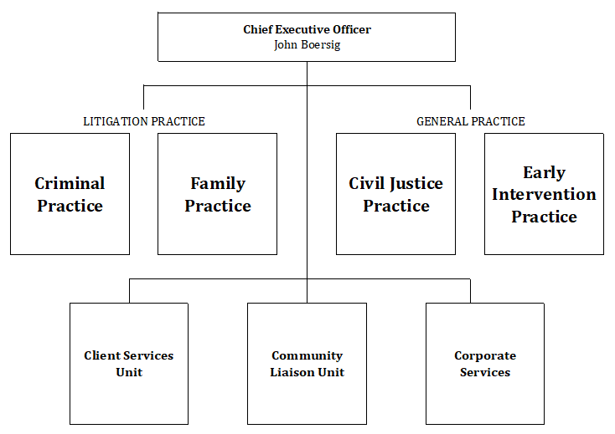

Position Dimension and Relationships
The Practice Supervisor supports the Head of Practice to efficiently manage the administration of lawyers and support staff within the Practice so they work cooperatively and coherently together, to identify and respond to the needs of the practice both professionally and administratively, and by providing strategic and operational advice on work functions and efficiencies.

Position Overview
The Practice Supervisor will be required to manage the administrative aspects of the Practice, maintain and oversee rostering of lawyer and legal support, and support the Head of Practice with strategic initiatives. The Practice Supervisor will be a participative and positive team member in a dynamic work environment, and will require strong attention to detail, excellent communication skills to ensure effective client and stakeholder service delivery and a high level of flexibility and adaptability in a rapidly changing environment.

The role will include but is not limited to:
Practice Administration
- Manage the administrative aspects of the Practice by:
- coordinating work priorities across the work group of Legal Support Officers
- distributing and re-allocating work priorities as staffing or work levels change
- identifying improvements and creating solutions to procedural practices to properly support the needs of the Practice
- liaising with other Practices and work groups within the Commission and external stakeholders
- managing attendance, training and development of the Practice’s Legal Support Officers
- undertaking performance and review discussions with the Practice’s Legal Support Officers
- Support the Head of Practice:
- to efficiently manage the administration of Practice lawyers and support staff so they work cooperatively and coherently together
- to identify and respond to the needs of the Practice both professionally and administratively
- by providing strategic and operational advice on work functions and efficiencies
- Encourage and support ethical work practices and activities in line with organisational priorities
Staff Supervision
- Maintain and oversee rostering, including reporting and recording systems that support the Practice’s Legal Support Officers to undertake their roles
- Recruit, select, onboard and train employees and develop personal growth opportunities
- Plan, monitor and appraise work performance
- Implement and enforce systems, policies and procedures
Corporate Responsibilities
- Represent Legal Aid in a professional manner by upholding the ACT Public Service Values
- Contribute to continuous business process improvement and the development of policies and procedures
- Build professional relationships with employees and managers across Legal Aid to deliver high-quality and seamless service delivery
- Work towards performance objectives and KPIs identified in strategic, operational and individual performance development plans
- Be responsible for applying WHS to daily tasks performed in the workplace, report all matters beyond your authority and take all practical measures to ensure that your workplace is safe and without risk to health or property
- Comply with all Legal Aid ACT policies and procedures
- Perform other duties as directed, consistent with the classification level of the position and in line with competencies

Position Requirements
The information below describes the capabilities that are required to perform the duties and responsibilities of the position.

Professional / Technical Skills and Knowledge
- Knowledge of and experience in administrative practices
- Analytical skills, attention to detail accuracy
- Experience in Dynamics would be an advantage

Behavioural Capabilities
- Demonstrated ability to lead a team in a fast-paced professional environment
- Sound organisational skills, including the ability to effectively manage multiple tasks, determine priorities and meet strict deadlines in high pressure situations
- Ability to listen to and communicate clearly (both in writing and verbally) with staff at all levels and focus on customer service needs and satisfaction
- Ability to work cooperatively and positively within a team environment and demonstrate helpful, collaborative assistance to support colleagues within the Practice and across Legal Aid
- Ability to prioritise self-care for mental health and wellbeing

Compliance
- Current Working with Vulnerable People (WwVP) certification

