Classroom Teacher

Applicant Information Pack

January 2026



Contents

About the ACT Education Directorate 3
ACT public schools 4
Advice for applicants 5
The selection process 8
Links to further information 9

About the ACT Education Directorate
Thank you for your interest in lodging an application for a Classroom Teacher role with the ACT Education Directorate to work in ACT public schools.
We believe in the life changing impact of education. We are guided by the Future of Education Strategy, where our students are central to everything we do. The ACT public education system educates more than 50,000 students across 93 public schools, from early childhood schools to colleges.
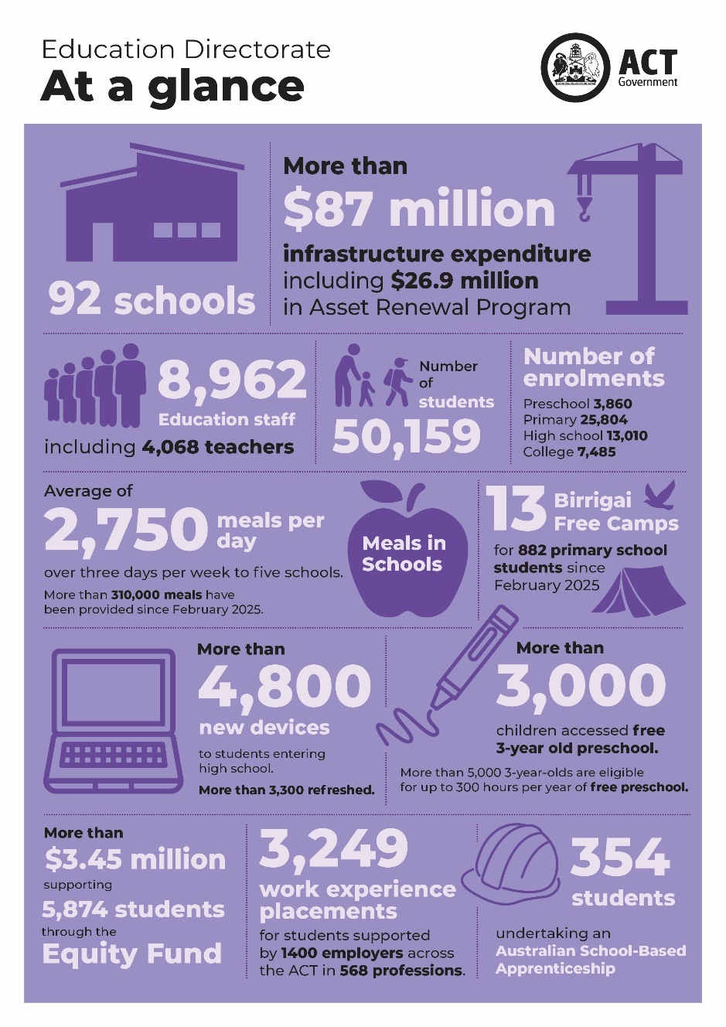
All ACT public schools teach the Australian Curriculum (V9.0) from kindergarten to year 10.

Through our Strong Foundations program, we are delivering a consistent evidence-based approach to learning across ACT public schools.

Our 93rd school, Strathnairn School in Belconnen, opened January 2026.

ACT public schools
In ACT public schools, you can use your teaching expertise in a range of school settings across 4 networks.
Our primary settings include preschool to year 6 primary schools and larger preschool to year 10 schools.
Our secondary settings include years 7 to 10 high schools, larger preschool to year 10 schools and colleges teaching years 11 and 12.
The ACT public education system also includes four specialist schools for students with moderate, severe or profound intellectual disability: Cranleigh School (kindergarten to year 6) and Black Mountain School (years 7-12) on Canberra’s northside and Malkara (preschool to year 6) and The Woden School (years 7-12) on the southside.
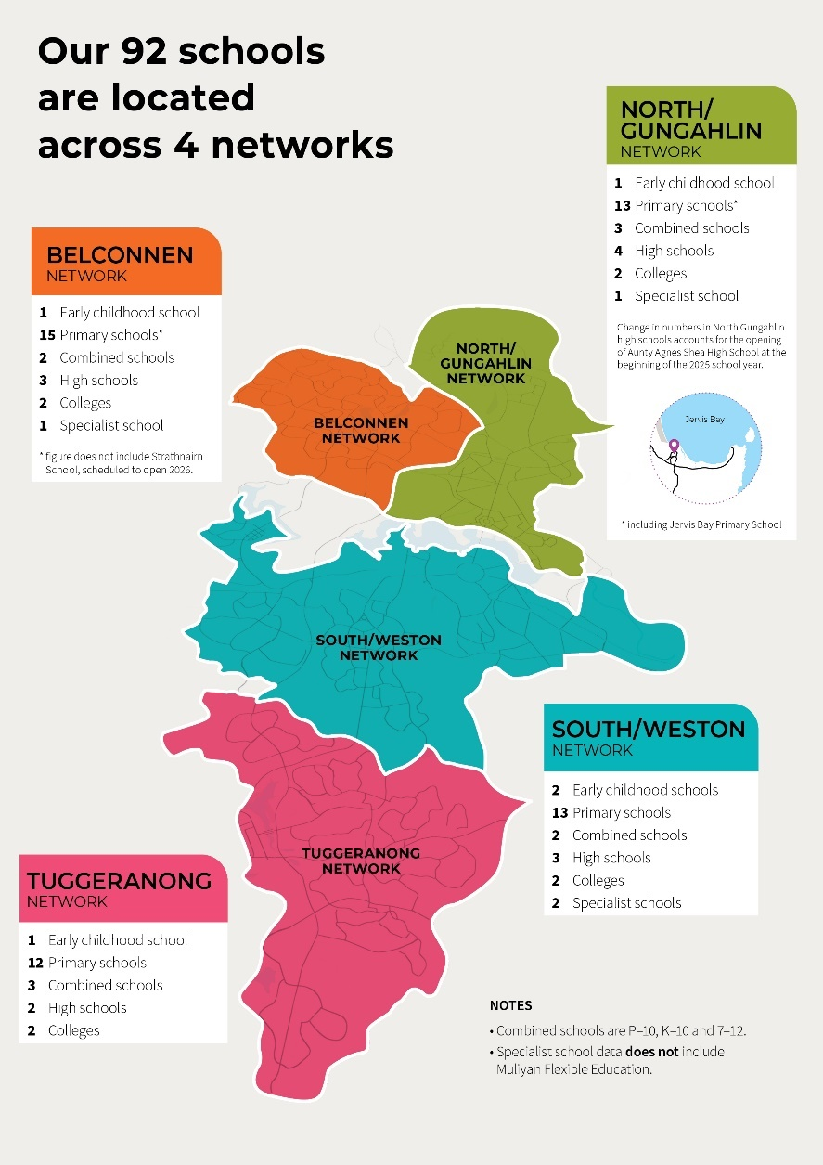
Students with disability and diverse learning needs are welcome to attend their local school, where they will be supported with reasonable adjustments. ACT public schools have access to the Education Directorate’s Allied Health Service, School Psychology Service and evidence-based professional learning.

Our 93rd school, Strathnairn School in Belconnen, opened January 2026.

Advice for applicants
The ACT Public Service is committed to applying the principles of merit-based selection, equity and diversity and procedural fairness in our recruitment processes.
Visit the website for further details on how we hire.

Eligibility requirements for employment
To be able to teach within the ACT public education system you must demonstrate:
- Education qualifications – Have an approved four-year full-time tertiary education qualification. Applicants with qualifications gained outside of Australia should complete a skills assessment by the Australian Institute for Teaching and School Leadership (AITSL) to confirm qualification requirements and English language proficiency to teach in Australian schools. Detailed information is available from the AITSL website.
- Teacher registration – Hold a valid approval to teach with the ACT Teacher Quality Institute (TQI). If you do not hold a teacher registration with the ACT TQI, we suggest starting your application process at the same time as you apply for this teaching opportunity. Teachers holding registration in another Australian state or territory or New Zealand are eligible for mutual recognition.
- Working With Vulnerable People (WWVP) registration – Have a valid ACT WWVP. If you don’t, we suggest starting your application process at the same time.
- Approved working status – Be an Australian citizen and/or be permanent resident and/or hold a valid working visa. Business sponsorship is available and assessed on an individual basis. Email teachingincanberra@act.gov.au to find out more.

Application documents
Applicants are required to provide the following to complete their application:
- A statement, up to three pages, addressing the AITSL Standards (Australian Professional Standards for Teachers).
- Your resume/CV outlining your teaching experience and qualifications.
- Evidence of your teacher registration or, if currently studying, evidence of your enrolment in an accredited initial teacher education course.
- Details of two teaching referees from the past 5 years. At least one referee must be a current or former supervisor.

Statement addressing AITSL Standards
Classroom teachers are expected to enact professional knowledge, practice and engagement consistent with the Australian Professional Standards for Teachers.
Your statement should be structured to address each standard in the three overarching domains:
- Professional Knowledge
- Professional Practice
- Professional Engagement

Professional Knowledge
- Know students and how they learn
- Know the content and how to teach it

Professional Practice
- Plan for and implement effective teaching and learning
- Create and maintain supportive and safe learning environments
- Assess, provide feedback and report on student learning

Professional Engagement
- Engage in professional learning
- Engage professionally with colleagues, parents/carers and the community

Organise your statement with the following seven Standards as sub-headings:
Standard 1 – Know students and how they learn
Standard 2 – Know the content and how to teach it
Standard 3 – Plan for an implement effective teaching and learning
Standard 4 – Create and maintain supportive and safe learning environments
Standard 5 – Assess, provide feedback and report on student learning
Standard 6 – Engage in professional learning
Standard 7 – Engage professionally with colleagues, parents/carers and the community
Each Standard has several focus areas. Do not try to address every focus area within a standard. Choose one or two focus areas and write to how you have strived to meet that standard.
For example: Standard 3: Plan for and implement effective teaching and learning
- Establish challenging learning goals
- Select and use resources

Descriptor at career stage
Graduate | Proficient | Highly accomplished | Lead
Focus area 3.1 Established challenging learning goals
Set learning goals that provide achievable challenges for students of varying abilities and characteristics. | Set explicit, challenging and achievable goals for all students. | Develop a culture of high expectations for all students by modelling and setting challenging goals. | Demonstrate exemplary practice and high expectations and lead colleagues to encourage students to pursue challenging goals in all aspects of their education.

Write using the STARRL method and give concrete examples.
Situation
Task
Action
Result
Reflection
Learning

Referees
In choosing referees, consider how well they know your work and can speak about your capabilities. Please ensure that you have spoken to your nominated referees before submitting their details. For the interview panel to deliver a timely outcome to candidates it is preferred that the reference check is completed prior to interview. The focus may, in general terms, relate to the capabilities or a specific aspect for which clarification would assist the selection panel in making their decision.

The selection process
All applications will be assessed by a Joint Selection Committee (JSC) composed of three individuals. This may include school principals, school leaders and classroom teachers.
The JSC will apply the principles of merit when selecting candidates, including short listing, interviewing and refereeing (not necessarily in this order) to determine a list of suitable applicants. These standard selection techniques may be supplemented by other assessment techniques that the selection committee considers necessary.
Candidates invited to interview will have an online interview scheduled. Candidates will receive, via email, the interview questions 30 minutes prior to the commencement of the interview, allowing you to prepare your responses.
All candidates will be interviewed by the JSC composed of three individuals of varying gender and experience, including school principals, leaders and classroom teachers.
Interviews will be for approximately 20 minutes. You will have the opportunity to ask questions following the formal interview.
Applicants will be notified of your outcome following completion of the selection process. Applicants will be found either ‘suitable’ or ‘unsuitable’.
Following a ‘suitable’ outcome, principals with vacancies in their schools will contact you directly in relation to employment opportunities.

Links to further information
For more information about our public schools and working in ACT public schools visit the ACT Education Directorate website.
Additional useful links are listed below:

The Education Directorate Annual Report
Future of Education: An ACT education strategy for the next 10 years
Inclusive Education: A Disability Inclusion Strategy for ACT Public Schools 2024-2034
Strong Foundations program
The ACT Education Directorate Strategic Plan
ACT Public Sector Education Directorate (Teaching Staff) Enterprise Agreement 2023-2026
ACT Education Directorate pay and benefits

