Temporary and Permanent School Assistant

Applicant Information Pack

February 2026



Contents

About the ACT Education Directorate 3
ACT public schools 4
Role of a School Assistant 5
Advice for applicants 7
The selection process 12
Links to further information 13

About the ACT Education Directorate
Thank you for your interest in lodging an application for a School Assistant role with the ACT Education Directorate to work in ACT public schools.
We believe in the life changing impact of education. We are guided by the Future of Education Strategy, where our students are central to everything we do. The ACT public education system educates more than 50,000 students across 93 public schools, from early childhood schools to colleges.
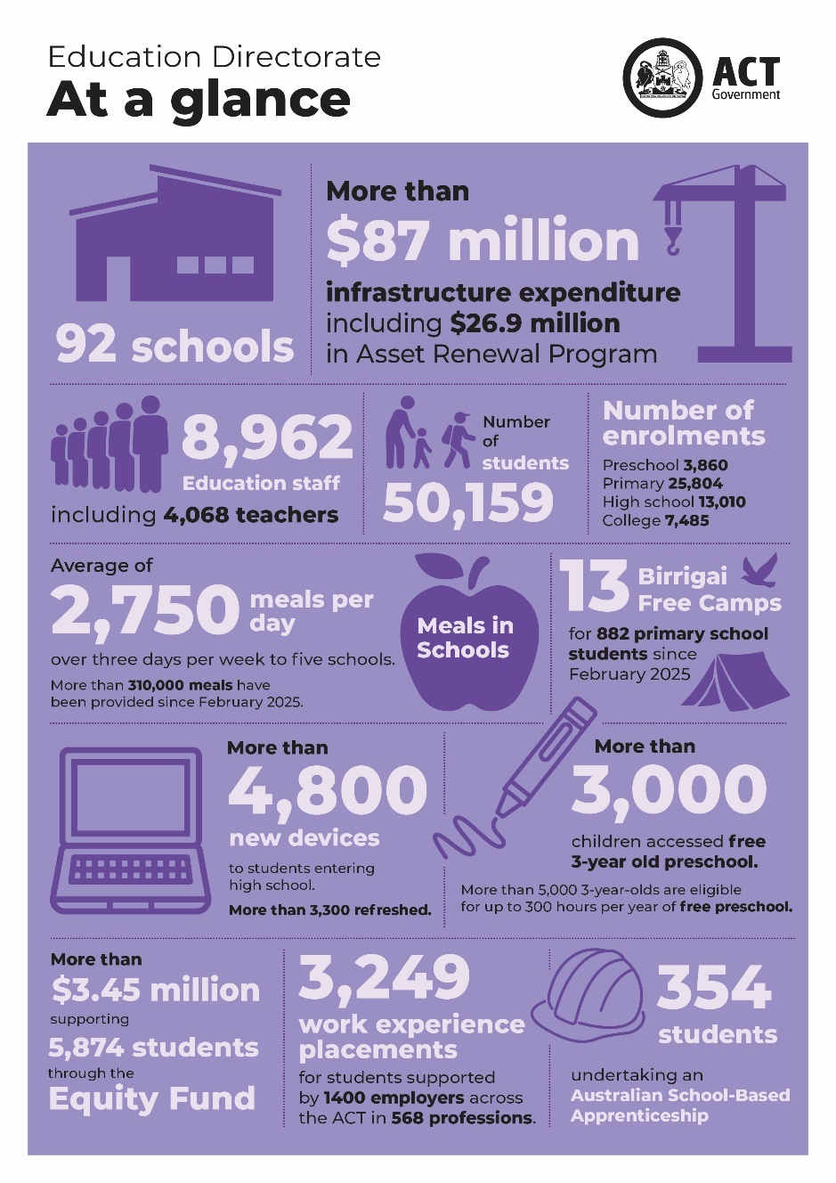
All ACT public schools teach the Australian Curriculum (V9.0) from kindergarten to year 10.

ACT colleges use a different system, set by the Board of Senior Secondary Studies (BSSS). Instead of relying on final exams, students are assessed through school-based tasks across years 11 and 12. The only external test is the ACT Scaling Test (AST) in Year 12.

Through our Strong Foundations program, we are delivering a consistent evidence-based approach to learning across ACT public schools.

Source: 2024-25 ACT Education Directorate Annual Report.

ACT public schools
In ACT public schools, school assistants support school leaders and teachers in a range of school settings across 4 networks.
Our primary settings include preschool to year 6 primary schools and larger preschool to year 10 schools.
Our secondary settings include years 7 to 10 high schools, larger preschool to year 10 schools and colleges teaching years 11 and 12.
The ACT public education system also includes four specialist schools for students with moderate, severe or profound intellectual disability: Cranleigh School (kindergarten to year 6) and Black Mountain School (years 7-12) on Canberra’s northside and Malkara (preschool to year 6) and The Woden School (years 7-12) on the southside.
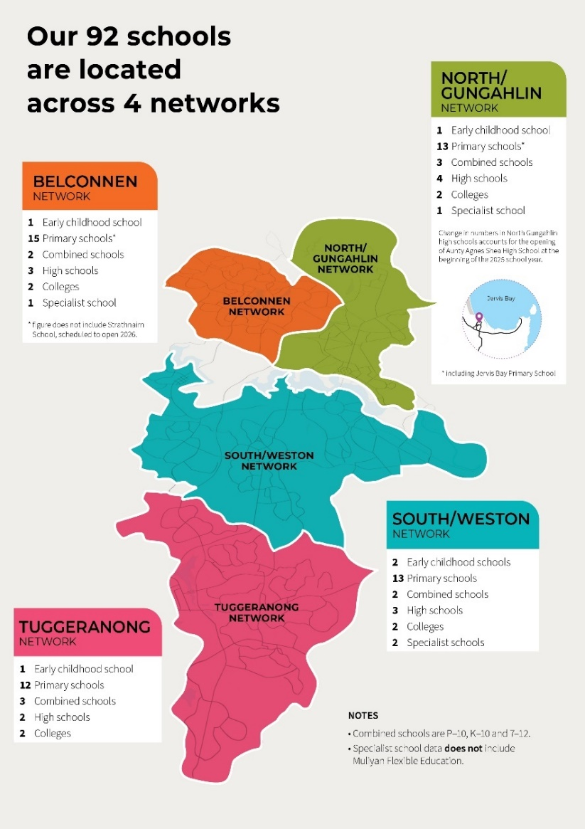
Students with disability and diverse learning needs are welcome to attend their local school, where they will be supported with reasonable adjustments. ACT public schools have access to the Education Directorate’s Allied Health Service, School Psychology Service and evidence-based professional learning.

Source: 2024-25 ACT Education Directorate Annual Report. Note our 93rd school, Strathnairn School opened in the Belconnen schools’ network in January 2026.

Role of a School Assistant
The school assistant classification covers a range of different roles within each school.
These roles are grouped into 5 functional streams.
Functional Stream | SA2/3 classification - local designations | SA3 classification –  local designations | SA4 classification –  local designations
Administration / Operations | - Administrative Assistant  - General Assistant | - Staffing Assistant | - Administrative Coordinator  - Executive Assistant
Learning Support | - Learning Support Assistant | Preschool Assistant – Koori  Preschool Assistant  Vision Support Assistant  Hearing Support Assistant  Bilingual Assistant
Student Services / Welfare | - Defence Transition Mentor  - Defence School Transition Aide |  | - Youth Support Worker  - Wellbeing Support Worker  - Transition to Work Coordinator
Technical / Professional | - Food Technology Assistant  - Technology Assistant  - Library Assistant | - Information Communication Technology Assistant  - Laboratory Assistant
Identified positions |  | - Aboriginal and Torres Strait Islander Education Worker | - Aboriginal and Torres Strait Islander Education Officer

Activities undertaken by a school assistant within the ACT public education system include:
- Providing routine support to teachers and students in classroom activities and in the implementation of educational programs; classroom support may include working with individual or small groups of students.
- Providing basic physical, emotional and personal hygiene and health care for students.
- Supporting teachers in monitoring students and in addressing student behavioural issues in learning environments.
- Operating work area equipment, assisting others in the routine use of equipment and organising or undertaking routine maintenance and repair of equipment as required.
- Maintaining a clean and safe working environment for students and staff in accordance with workplace health and safety standards and procedures.
- Providing general administrative support such as preparing standard correspondence, data entry, records management, student reporting, photocopying and secretariat support.
- Participating in the planning, development and implementation of educational programs; classroom support may include working with an individual or small group of students.

Advice for applicants
The ACT Public Service is committed to applying the principles of merit-based selection, equity and diversity and procedural fairness in our recruitment processes.
Visit the website for further details on how we hire.

Eligibility requirements for employment
To be able to work within the ACT public education system you must demonstrate:
- Working With Vulnerable People (WWVP) registration – Have a valid ACT WWVP. If you don’t, we suggest starting your application process at the same time.
- Approved working status – Be an Australian citizen and/or be permanent resident and/or hold a valid working visa.
- Minimum requirements for Preschool Assistant roles – All ACT public school preschool unit assistants are required to have or be working towards a minimum qualification requirement (Certificate III in Children's Services or equivalent) as detailed in the Education and Care Services National Law Act (ACT) 2011 and regulations.

Application documents
Applicants are required to provide the following to complete their application:
- A written application (maximum 3 pages) addressing the selection questions for the support area. Refer to the Applicant Pack for details.
- Evidence of WWVP registration and any relevant qualifications or, if currently studying, evidence of your enrolment in an accredited education course.
- Details of one referee (2 preferred), including one from your current or most recent supervisor.

Selection questions to address
As part of your application, you will need to submit a written response of up to 3 pages addressing the selection questions for each support area you are applying for.
If you wish to be considered for multiple support areas, please provide a separate written response for each one.
Refer to the table for the support assistant stream, position name and role description details as and the respective selection questions to address.

Administration / Operations
Position name | Role descriptions | Questions to address
- Administrative Assistant (SA2/3)  - General Assistant (SA2/3)  - Staffing Assistant (SA3)  - Administrative Coordinator (SA4)  - Executive Assistant (SA4) | Roles within the Administrations/ Operations stream provide a range of administrative services for schools in support of staff, parents/carers, students and external stakeholders. This may include:  - preparing documentation such as school circulars, newsletters and other communication or promotional material  - performing customer service tasks such as reception duties, attending to school visitors, parents/carers, staff and students, and responding to routine enquiries  - coordinate school staff relief and associated processes,  - participating in the planning and coordination of school events such as student excursions, open nights and parent teacher interviews  - maintaining a clean and safe work environment for students and staff. | - Describe the strategies you would implement to support students, colleagues and the community to effectively maintain the operations of a school environment.  - How would you build and maintain effective relationships with colleagues and communities?  - How would you communicate effectively with students or colleagues to ensure you are understood?  - Can you provide an example of when you have had to prioritise multiple tasks to meet deadlines?  - Can you provide an example of when you have had to work independently and as part of a team to complete a task?  - Can you provide an example of how you would apply and maintain work, health and safety practices in the workplace in the context of the role you are applying for?
Learning Support
Position name | Role descriptions | Questions to address
- Learning Support Assistant (SA2/3)  - Preschool Assistant – Koori (SA3)  - Preschool Assistant (SA3)  - Vision Support Assistant (SA3)  - Hearing Support Assistant (SA3)  - Bilingual Assistant (SA3) | Roles within the Learning Support stream provide support to teachers and students who have intellectual and/or physical disabilities in classroom activities and may include:  - working with individual students or small groups  - providing physical support, emotional support and personal hygiene and health care for students  - assisting with the implementation of approved specialist programs  - providing specialist hearing, vision or bilingual support to students. | - Describe the strategies you would implement to support students in their learning and development to achieve positive educational outcomes, noting students may have intellectual and/or physical disabilities.  - How would you build and maintain effective relationships with colleagues and communities?  - How would you communicate effectively with students or colleagues to ensure you are understood?  - Can you provide an example of when you have had to prioritise multiple tasks to meet deadlines?  - Can you provide an example of when you have had to work independently and as part of a team to complete a task?  - Can you provide an example of how you would apply and maintain work, health and safety practices in the workplace in the context of the role you are applying for?
Learning Support
Position name | Role descriptions | Questions to address
- Defence School Transition Aide (SA2/3)  - Defence Transition Mentor (SA2/3)  - Youth Support Worker (SA4)  - Wellbeing Support Worker (SA4)  - Transition to Work Coordinator (SA4) | Roles within the Student Services/Welfare stream provide in school support and mentoring to students and may include:  - coordinate school activities that support transition and inclusion of Australian Defence Force (ADF) students  - developing, implementing and managing programs aimed at providing support for student wellbeing and positive behaviour  - monitoring student behaviour in learning environments and identify strategies to support students to fulfill their potential. | - Describe the strategies or programs you would implement to support existing and transitioning students to achieve positive educational outcomes.  - How would you build and maintain effective relationships with colleagues, communities and external stakeholders?  - How would you communicate effectively to students or colleagues to ensure you are understood?  - Can you provide an example of when you have had to prioritise multiple tasks to meet deadlines?  - Can you provide an example of when you have had to work independently and as part of a team to complete a task?  - Can you provide an example of how you would apply and maintain work, health and safety practices in the workplace in the context of the role you are applying for?
Technical / Professional
Position name | Role descriptions | Questions to address
- Food Technology Assistant (SA2/3)  - Technology Assistant (SA2/3)  - Library Assistant (SA2/3)  - Information Communication Technology Assistant (SA3)  - Laboratory Assistant (SA3) | Roles within the Technical/ Professional stream provide advice to teachers on a range of technical on food and materials for practical lessons, technical and procedural on safe operation of machinery provide support to teachers and students who have intellectual and/or physical disabilities in classroom activities and may include:  - assisting in the operations of a food/hospitality or a technology/industrial arts program  - coordinating the operation of ICT including maintenance of the school network and installation of equipment  - operation of a school library  - applying technical knowledge and support to teachers and students in the implementation of educational programs  coordinating the operations of a science laboratory including the safe storage, handling and disposal of chemicals and equipment | - Describe how you would advise and coordinate the operations of an educational program to achieve positive student outcomes in the context of the role you are applying for.  - How would you build and maintain effective relationships with colleagues and communities?  - How would you communicate effectively to students or colleagues to ensure you are understood?  - Can you provide an example of when you have had to prioritise multiple tasks to meet deadlines?  - Can you provide an example of when you have had to work independently and as part of a team to complete a task?  - Can you provide an example of how you would apply and maintain work, health and safety practices in the workplace in the context of the role you are applying for?
Technical / Professional (continued)
Position name | Role descriptions | Questions to address
 | - Maintain a clean and safe working environment for students and staff in accordance with workplace health and safety standards and procedures.

When completing your written assessment, you can use the STAR method to effectively showcase your skills and experiences.
Below is a breakdown of how you could structure your responses:

Situation
- Describe the context within which you performed a task or faced a challenge. Be specific to give a clear picture.
- Example: "While working as a school assistant, I noticed that several students were struggling with their reading skills."

Task
- Explain the actual task or responsibility you had in that situation. This helps the reader understand your role.
- Example: "I was tasked with developing a reading support program to help these students improve their literacy."

Action
- Describe the specific actions you took to address the task. Focus on what you did, rather than what the team did.
- Example: "I created a weekly reading club, selected age-appropriate books, and organised one-on-one reading sessions with the students. I also collaborated with teachers to integrate reading activities into the classroom."

Result
- Share the outcomes of your actions. Quantify your success if possible and explain how your actions made a difference.
- Example: "As a result, the students' reading levels improved significantly over the semester, with many advancing by two reading levels. Teachers and parents also reported increased enthusiasm for reading among the students."
Using the STAR method helps you provide clear, concise, and compelling examples of your skills and achievements.

Referees
You are required to provide the contact details of one referee, however two is preferable, with at least one from your current or most recent supervisor.

In choosing referees, consider how well they know your work and can speak about your capabilities. Please ensure that you have spoken to your nominated referees before submitting their details. For the interview panel to deliver a timely outcome to candidates it is preferred that the reference check is completed prior to interview. The focus may, in general terms, relate to the capabilities or a specific aspect for which clarification would assist the selection panel in making their decision.

The selection process
Selection Advisory Committees (SACs) are required to assess the suitability of applicants seeking permanent or temporary employment. These committees will apply merit-based principles and typically consist of three members, which may include representatives from the Executive Support Office and school-based staff.
The SAC will apply the principles of merit when assessing applicants’ suitability. Applicants will be assessed by the SAC based on their written application, interview and referee reports to determine a merit pool of suitable applicants. These standard selection techniques may be supplemented by other assessment techniques that the selection committee considers necessary.
Candidates invited to interview will have an online interview scheduled. Candidates will receive, via email, the interview questions 15 minutes prior to the commencement of the interview, allowing you to prepare your responses.
All candidates will be interviewed by the SAC composed of three individuals, including executive support office representatives and school-based staff.
Interviews will be for approximately 20 minutes. You will have the opportunity to ask questions following the formal interview.
Applicants will be notified of your outcome following completion of the selection process. Applicants will be found either ‘suitable’ or ‘unsuitable’.
Following a ‘suitable’ outcome, principals with vacancies in their schools will contact you directly in relation to employment opportunities.

Links to further information
For more information about our public schools and working in ACT public schools visit the ACT Education Directorate website.
Additional useful links are listed below:

The Education Directorate Annual Report
Future of Education: An ACT education strategy for the next 10 years
Inclusive Education: A Disability Inclusion Strategy for ACT Public Schools 2024-2034
Strong Foundations program
The ACT Education Directorate Strategic Plan
ACT Public Sector Education Directorate (Teaching Staff) Enterprise Agreement 2023-2026
ACT Education Directorate pay and benefits

Please email us at EDUSchoolAssistant@act.gov.au with any questions when completing your application.

