

Position Description

Position Title | Legal Officer
Classification | Legal Officer 1 | Basis of employment | Ongoing or 12-month contract (with opportunity to become permanent)
Division | Legal | Position Number | P60180
Location | Canberra | Salary | $80,862 - $156,562 + superannuation
Reporting To | Managing Principal Lawyer
Contact details | Priyanka Koci  02 5132 9323  priyanka.koci@integrity.act.gov.au
Important information
Applicants must have admission (or eligibility to be admitted) as a practitioner of the Supreme Court of an Australian State or Territory.
A security clearance, or the ability to obtain and maintain a security clearance at Negative Vetting Level 1 (NV1).

About the Commission
The ACT Integrity Commission (the Commission) is an independent integrity agency with powers under the Integrity Commission Act 2018 (the IC Act) to investigate, expose and prevent corruption, and foster public confidence in the integrity of government.
Under the Public Interest Disclosure Act 2012 (the PID Act), the Commission is also responsible for receiving, assessing, referring, and investigating reports of disclosable conduct and deciding which reports are to be treated as Public Interest Disclosures (PIDs). The Commission performs an oversight role of ACT public sector agencies and their management of PIDs.

Our functions
The Commission’s functions are to:
- investigate allegations of corrupt conduct
- refer suspected instances of criminality or wrongdoing to the appropriate authorities
- prevent corruption through research and mitigation efforts
- publish information about investigations, including lessons learned
- provide education programs
- foster public confidence in the Legislative Assembly and ACT public sector
- receive, assess, refer, and investigate reports of disclosable conduct and
- oversee ACT public sector agency management of public interest disclosures

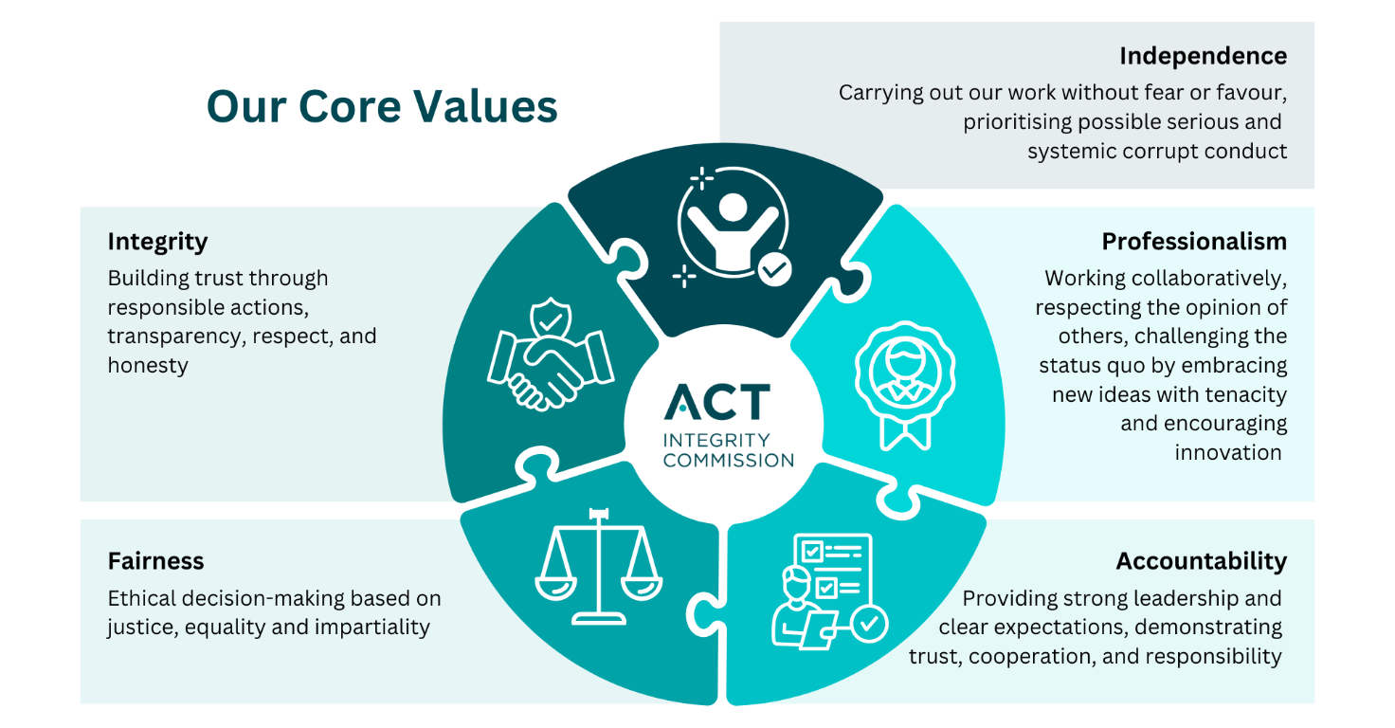

Legal team overview
The Commission’s multidisciplinary approach to the exercise of its functions means its lawyers are involved in a range of functions that have legal elements. The small team of lawyers and other support staff, under the direction of General Counsel and the Managing Principal Lawyer, are responsible for the legal aspects of the Commission’s work.
Members of the Legal Team:
- collaborate with other teams to assess and investigate complaints of corrupt conduct within the ACT public sector;
- provide legal advice to the Commissioner and Commission staff on all aspects of the Commission’s operations, both operational and administrative;
- act as solicitors in connection with investigations and in litigation involving the Commission;
- instruct external Counsel Assisting the Commission in witness examinations;
- instruct counsel appearing for the Commission in litigation;
- act as Counsel Assisting the Commissioner in the conduct of witness examinations;
- prepare and assist with the preparation of the Commission’s investigation and other reports;
- manage processes relating to freedom of information requests and conflicts of interest; and draft documents necessary for a variety of processes under the IC Act.

Position overview
The Legal Officer will work under the supervision of senior lawyers and the General Counsel. The Legal Officer reports to the Managing Principal Lawyer. The Legal Officer will be responsible for the provision of high-quality legal support to the Commission’s Legal Team to ensure it is fully supported in the delivery of legal services to the Commission.
In this role, the Legal Officer is expected to apply professional knowledge and skills in law and legal practice to:
- Conduct legal research and analysis of caselaw and other legal material, and prepare high quality, timely memoranda on legal issues.
- Prepare draft legal advice for review by senior lawyers on a range of issues, including on operational matters within the Commission as well as issues arising in investigations.
- Assist with the progression of investigations by providing legal advice, assisting with warrant applications and drafting investigation reports.
- Draft routine legal documents such as letters, confidentiality notices, non-disclosure notices, summonses,and other documents issued by the Commission under the Integrity Commission Act 2018 (ACT).
- Co-ordinate and liaise with legal and administrative staff within the Commission to facilitate public and private examinations.
- Prepare draft examination plans and draft observations for Counsel Assisting for examinations.
- Appear as Counsel Assisting in examinations, or be willing to develop the advocacy skills required to do so.
- Appear on behalf of the Commission in the ACT Supreme Court and/or other courts or tribunals as required.
- Instruct counsel in the ACT Supreme Court and/or other courts or tribunals as required.
- Assist with the preparation of reports on assessment of incoming matters and investigations as required.
- Conduct high-volume document review, draft chronologies and other summary documents, and compile briefs of evidence.
- Maintain and update Legal template documents.
- Maintain and update the Legal advice database ensuring that it remains current.
- Maintain records in accordance with the Territory Records Act 2002.
- Assessing and assist in responding to Freedom of Information requests in accordance with applicable legislation.
- Respond to Notice to Produce Information requests.
- Contribute to the preparation and revision of internal processes, procedures and guidance material to facilitate the work of the legal branch and other areas of the Commission.
- Engage and maintain relationships with external stakeholders.
- Contribute to legal knowledge within the Commission through a commitment to continued legal education and training.
- Contribute to CPD activities for the Legal team.
In addition to the activities above, the Legal Officer may from time to time be asked to undertake tasks that are outside their usual span of duties but are within the range of their capabilities. Supporting one another in this way provides opportunities for exposure across the agency and is an integral part of the Commission’s positive workplace culture.
As a representative of the Commission, the Legal Officer must be a role model for professionalism
and integrity within the ACT public sector, the broader ACT community, and the legal profession.

What you will do

  - Engage in operational effectiveness through:
  - using initiative to identify problems and issues and effective responses
  - effectively prioritising work and ensure tasks are completed within deadlines, and
  - assisting senior lawyers in the preparation of matters for examination/legal proceedings in a timely and efficient fashion.

  - Demonstrate high level interpersonal and communication skills, through ensuring:
  - information is clearly and effectively presented through oral and written means
  - relevant people are kept informed of decisions and other key information in a timely manner
  - contributions to joint projects and staff meetings are positive and collaborative, and
  - records are maintained in accordance with legislative requirements and Commission policies.

  - Demonstrate a commitment to growth, through:
  - taking ownership over the role and seeking to develop and apply high quality and consistent processes and procedures throughout the Commission
  - strengthening service within the Legal Team
  - promptly responding to and addressing performance issues raised
  - identifying experiences relevant to the performance of the Legal Team and sharing them within the Legal Team, and
  - identifying personal developmental needs and communicating them to the General Counsel.

  - Make a positive contribution to the Commission’s culture by:
  - promoting a culture of continuous personal and organisational improvement through positive personal behaviours, and recognition of the role the Commission plays in ensuring human rights are upheld and supported, and
  - at all times, acting in an ethical and respectful manner, consistent with Work Health and Safety, Equal Employment Opportunity, diversity, and employee well-being requirements.

What you require (Selection criteria)

Essential criteria
The following four areas form the criteria required to perform the duties and responsibilities of the position (criteria are essential unless designated as highly desirable or desirable):
Professional experience - Essential
- Proficiency in legal research and analysis, including by utilising LexisNexis and/or Westlaw.
- Proficiency in Microsoft Office suite and the ability to quickly learn new programs/databases.
- Demonstrated ability to understand and analyse complex data and present complex factual and legal arguments clearly and persuasively in both written and oral submissions.
- Strong time management skills including the ability to work under pressure and see activities through to completion.
- Demonstrated knowledge of the rules of procedural fairness.

Professional experience - Desirable
- Relevant experience in an office or legal environment
- Experience in the preparation of court documents and knowledge of court, tribunal and/or other integrity or royal commission systems
- Experience in criminal and/or civil advocacy, involving adducing, testing evidence, and making submissions as to law and fact
- Understanding of the structures and operational arrangements of the public sector.
Behavioural capabilities
- Strong Organisational Skills: a proactive approach, enthusiasm and demonstrated ability to manage and prioritise multiple tasks to meet deadlines
- Analytical and Problem-Solving skills: demonstrate a clear, methodical approach to tasks, Sound judgment, high level oral and written communication skills
- Teamwork: The ability to work effectively and collaboratively within a team environment, as well as work independently. Ability to apply feedback and show personal drive, courage, and integrity and the willingness to undertake a variety of tasks to meet business needs.
- Perseverance and attention to detail: show resilience, tenacity, a commitment to excellence and professionalism and an ability to achieve results.
Qualifications
- Admission (or eligibility to be admitted) as a practitioner of the Supreme Court of an Australian State or Territory.
- A restricted practising certificate or the ability to obtain one.
- The successful applicant will be required to obtain and maintain a Commonwealth security clearance at the Negative Vetting Level 1 (NV1) classification; accordingly, applications can only be considered from those with Australian citizenship.

How to apply
Applications for the position should be submitted online via the jobs.act.gov.au website.
Applications must include:
  - A current resume, and
  - A written response (a pitch) of 750 words or less that:
    - demonstrates how your skills, knowledge and experience address the criteria outlined in the ‘What you require’ section of the position description, and
    - outlines why you want the job and why you believe you are the best person for the position.
  - Contact details for two referees, one of which must be your current or most recent supervisor.

If you are unable to submit your application online, please contact the Contact Officer.

Note: if you are shortlisted for further assessment, you may be asked to undertake a written task to further demonstrate your capabilities.

