

Position Description

Position Title | Investigative Assistant
Classification | Administrative Services Officer Class 5 (ASO5)
Salary | $95,722 - $100,956 + superannuation
Location | Canberra
Position Number | P68408
Reporting To | Assistant Director, Investigations
Position Requirements | A security clearance, or the ability to obtain and maintain a security clearance at the Negative Vetting Level 1 (NV1)
Contact Officer | Adelle Deakin  Adelle.deakin@integrity.act.gov.au
Last reviewed | 7 September 2026

Agency overview
The ACT Integrity Commission (the Commission) is an independent integrity agency with powers under the Integrity Commission Act 2018 (the IC Act) to investigate, expose and prevent corruption and foster public confidence in the integrity of government.
Under the Public Interest Disclosure Act 2012 (the PID Act), the Commission is also responsible for receiving, assessing, referring, and investigating reports of disclosable conduct and deciding which reports are to be treated as Public Interest Disclosures (PIDs), and performing an oversight role of ACT public sector agencies and their management of PIDs.
Our functions
The Commission’s functions are to:
- Investigate allegations of corrupt conduct
- Refer suspected instances of criminality or wrongdoing to the appropriate authorities
- Prevent corruption through research and mitigation efforts
- Publish information about investigations, including lessons learned
- Provide education programs
- Foster public confidence in the Legislative Assembly and ACT public sector
- Receive, assess, refer, and investigate reports of disclosable conduct, and
- Oversee ACT public sector agency management of public interest disclosures.

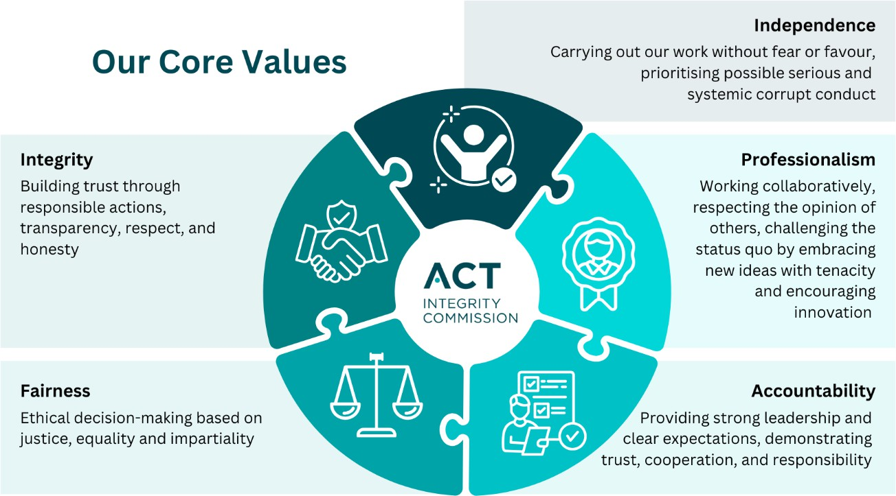

Business Unit Overview
The role of the Investigations team is to conduct investigations into alleged corrupt conduct under the Integrity Commission Act 2018. The team prioritises serious and/or systemic corrupt conduct.

Position Overview
Investigative Assistants support investigations by collecting, organising and analysing information, updating and maintaining investigation records, and undertaking general administrative tasks in support of the Commission’s investigative function.

What you will do
- Support Commission investigations and preliminary inquiries into allegations of corrupt conduct by:
  - Collecting, organising and analysing information and evidence;
  - Updating, maintaining and reviewing investigation records, ensuring records are accurate and easily accessible to others; and
  - Undertaking general administrative taskings.
- Where necessary and under guidance, prepare evidentiary material for Commission examinations or for referral to prosecution entities, ensuring evidentiary material is professionally presented in accordance with legislative requirements, internal policies and requirements.
- Draft and serve notices and summonses for evidential material or people to attend the Commission for an examination.
- Update and maintain standard operating procedures, policies, and guidance documents.
- Perform a secretariat role for meetings held to make decisions about operational matters.
- Engage with witnesses as required.
- Communicate within, and external to, the Commission in a professional, timely, clear and relevant way.
- Contribute to a positive culture of continuous personal and organisational improvement by ensuring appropriate personal behaviours and recognising the role the Commission plays in ensuring human rights are upheld and supported.
- Promote ethical practice, Work Health and Safety (WHS), Equal Employment Opportunity (EEO), diversity and employee well-being.
- Provide assistance to other business units within the Commission if and when required.

What you require (Selection Criteria)

Essential criteria
- Proven organisational abilities, problem solving, analytical and attention to detail skills.
- Ability to write well and communicate effectively with a wide range of people both within and external to the Commission.
- An enquiring mind and the ability to work effectively in a multi-disciplinary team-based environment.
- Personal drive and initiative.

Professional / Technical Skills and Qualifications
- A full driver’s licence is preferred but not essential.
- The position may involve some domestic travel.

Compliance Requirements
The successful applicant will be required to obtain and maintain a Commonwealth security clearance at the Negative Vetting Level 1 (NV1) classification; accordingly, applications can only be considered from those with Australian Citizenship.

How to apply
Applications for the position should be submitted online via the jobs.act.gov.au website. Applications must include:
- A current resume, and
- A written response (a pitch) of no more than 750 words which:
  - demonstrates how your skills, knowledge and experience address the criteria outlined in the ‘What you require’ section of the position description, and
  - outlines why you want the job and why you believe you are the best person for the position.
If you are unable to submit your application online, please contact the Assistant Director, Investigations on 02 5132 9315 or at Adelle.deakin@integrity.act.gov.au.
Note: if you are shortlisted for further assessment, you may be asked to undertake a written task to further demonstrate your capabilities.

